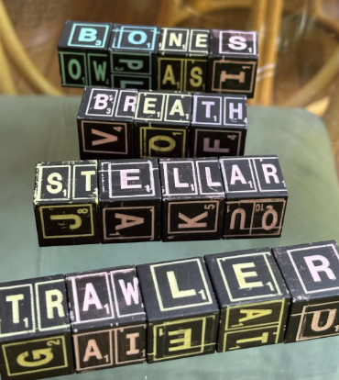 |  | Twisted Words  Twisted Words is played like extended variations of the classic word game Scrabble®. Players use magnetic letter cubes to create the most valuable words. Cubes are exchanged in a series of rounds until a winner is declared.
 | Game Play (One of five modes)  Give each player four cubes (if five players, provide three cubes). Simultaneously twist and rearrange your cubes to form your best, high-valued word. After two minutes, score your word. Based on the letters used, pass the two cubes with the highest- and lowest-valued letters to the person on your left. Repeat and play another round. After five rounds, the winner has the highest total score.  Lasercut-Etched Components:  16 hand-painted magnetic cubes.  Each cube has a vowel, two consonants and three bigrams (2-letter fragments). |  | Bonus: Vertical Game of Linking Words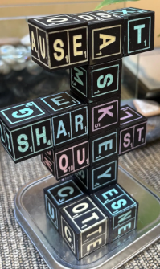  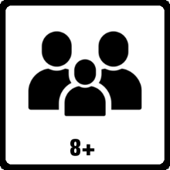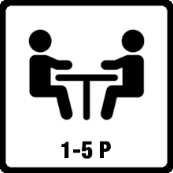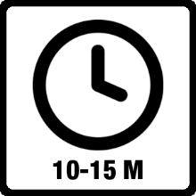  Copyright © 2025 www.Brainy.games

FIVE WAYS TO PLAY INSTRUCTIONS
MULTI-PLAYER GAME: (Build Your Best Words)
Setup – Each player starts with four cubes (3 cubes for 5 players). Grab a pen and paper for scoring.
Game Play - Twist and align your cubes to form the highest-scoring word possible within in one or two minutes. Score your word. Pass two cubes to the player on your left to shift the game dynamics. The cubes will be those with the highest and lowest values from the word you recorded. Repeat five rounds. Best Total Score Wins!

VERTICAL TOWER GAME: (Like 3D Scrabble®!)
Setup - Place a random cube between players as the base of a tower. This cube can be examined and rotated at first. Give each player two cubes. Choose to play cooperatively or competitively.
Game Play - Simultaneously attach cubes such that new words are made. Connect letters to an existing letter in any orientation as long as the letters are adjacent. Spanning through an inside corner is also allowed to make a word.

CROSSWORDS GAME: (Horizontal Tabletop Mode.)
Setup - Place one random cube in the middle of the table. This cube can be examined and rotated. Give each player an equal number of cubes. Choose to play cooperatively or competitively.
Game Play - Take turns adding cubes to make intersecting crosswords in any direction. Align using the top cubes only.

DAILY FRIDGE GAMES: (A Daily Family Challenge!)
Stick the cubes on your fridge (steel) door to compete with your family leaving new words each time you visit the fridge.
WORD SEARCH:
Setup – Arrange cubes in a 4x4 square. Grab a pen and paper for scoring.
Game Play – All players simultaneously call out words from adjacent letters and score their values. Letters can zig zag in all directions, but the same letter can only be used once. When no more words can be found, rearrange the cubes and play again. Play until someone reaches 100 points for the win.
Word Search Examples
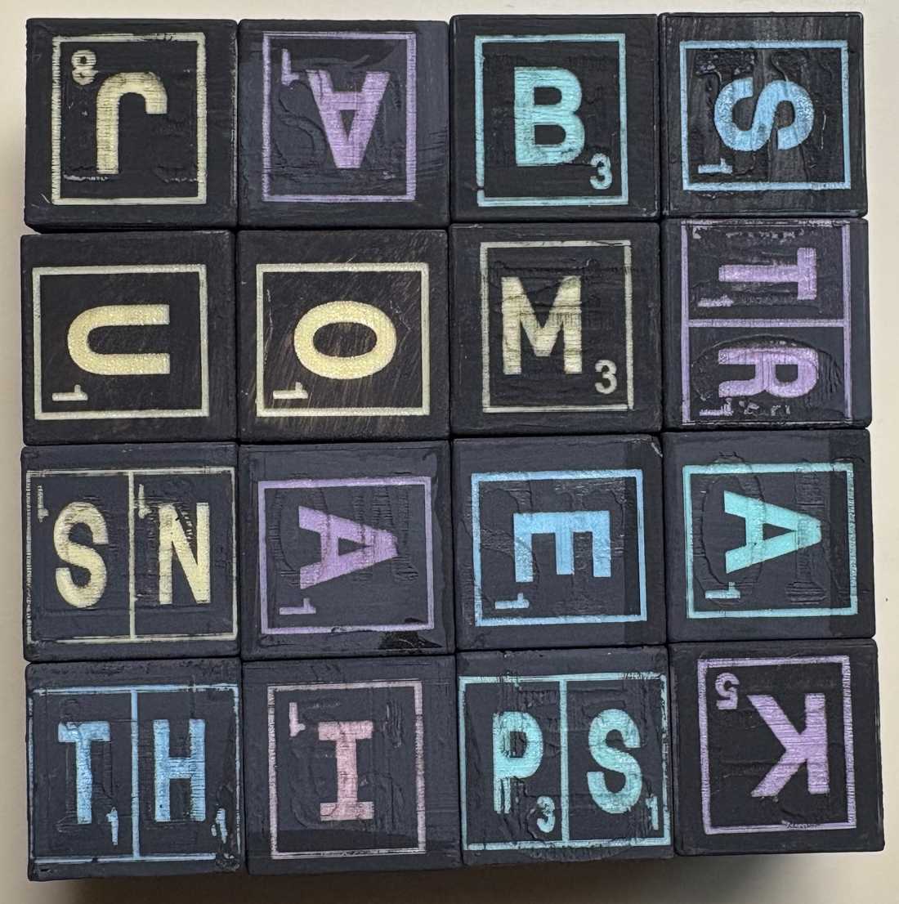  JABS MOBS THINS TRAPS  MOA MOANS JAM JAMS  TRAM MAKE MATH MAPS | 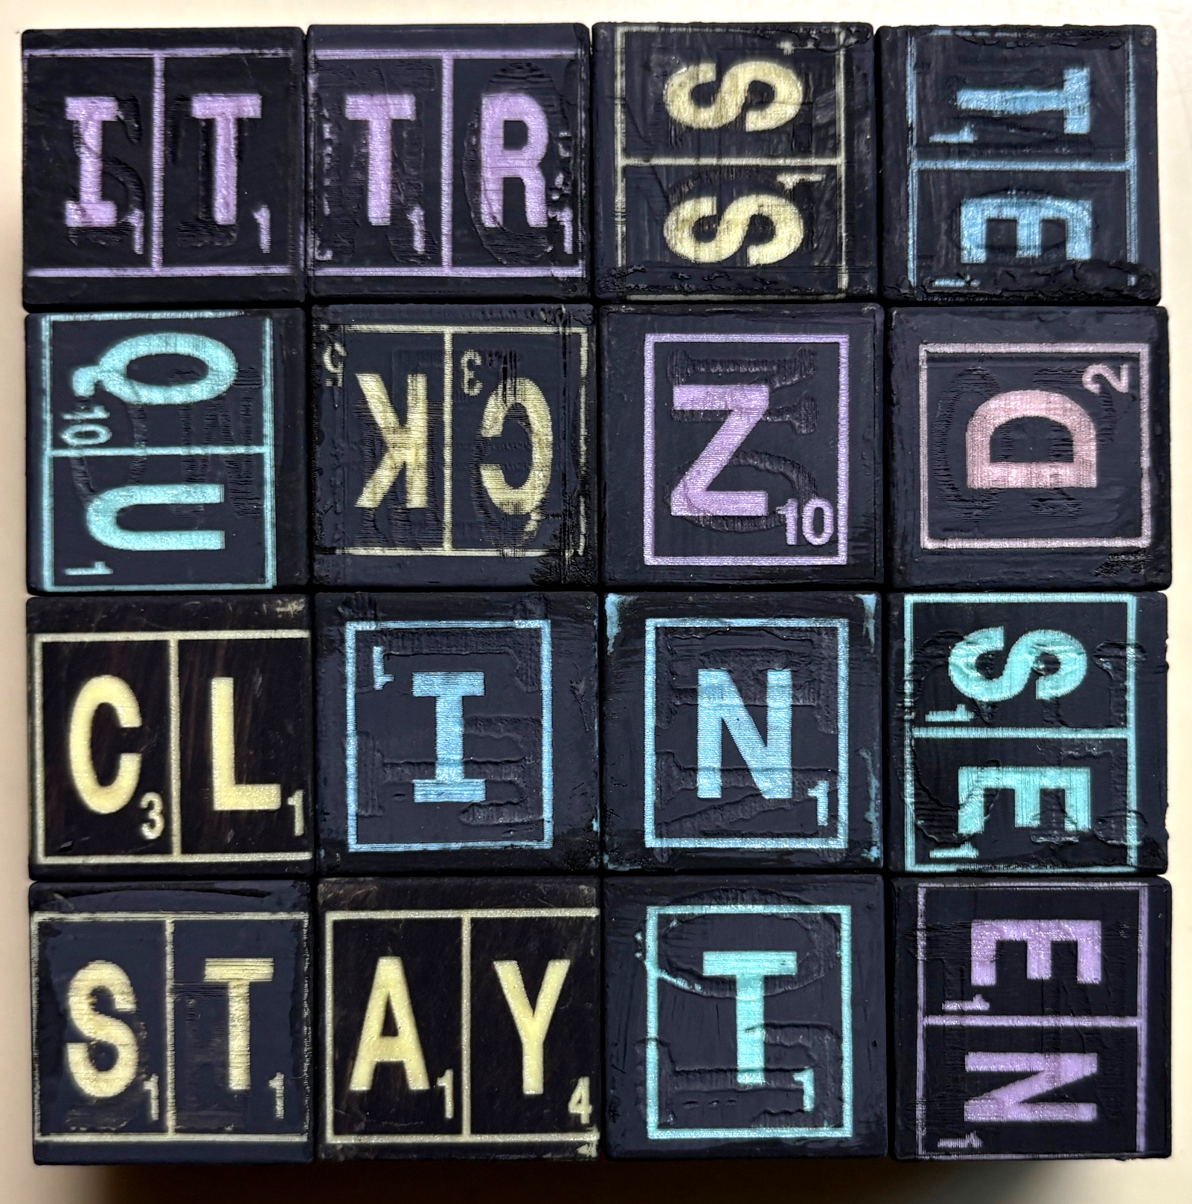  QUIT QUICK QUINT STAY  SEEN SET NAY TICK CLAY  CLICK NICK ZIT TEN TIN
SOLO GAME: Use all 16 cubes to construct at least four words and challenge yourself to find the best-scoring combinations!
These magnetic letter cubes open up a world of creative, strategic, and educational wordplay! Let us know if you’ve found other ways to play!

FIVE WAYS TO PLAY INSTRUCTIONS
MULTI-PLAYER GAME: (Build Your Best Words)
Setup – Each player starts with four cubes (3 cubes for 5 players). Grab a pen and paper for scoring.
Game Play - Twist and align your cubes to form the highest-scoring word possible within in one or two minutes. Score your word. Pass two cubes to the player on your left to shift the game dynamics. The cubes will be those with the highest and lowest values from the word you recorded. Repeat five rounds. Best Total Score Wins!

VERTICAL TOWER GAME: (Like 3D Scrabble®!)
Setup - Place a random cube between players as the base of a tower. This cube can be examined and rotated at first. Give each player two cubes. Choose to play cooperatively or competitively.
Game Play - Simultaneously attach cubes such that new words are made. Connect letters to an existing letter in any orientation as long as the letters are adjacent. Spanning through an inside corner is also allowed to make a word.

CROSSWORDS GAME: (Horizontal Tabletop Mode.)
Setup - Place one random cube in the middle of the table. This cube can be examined and rotated. Give each player an equal number of cubes. Choose to play cooperatively or competitively.
Game Play - Take turns adding cubes to make intersecting crosswords in any direction. Align using the top cubes only.

DAILY FRIDGE GAMES: (A Daily Family Challenge!)
Stick the cubes on your fridge (steel) door to compete with your family leaving new words each time you visit the fridge.
WORD SEARCH:
Setup – Arrange cubes in a 4x4 square. Grab a pen and paper for scoring.
Game Play – All players simultaneously call out words from adjacent letters and score their values. Letters can zig zag in all directions, but the same letter can only be used once. When no more words can be found, rearrange the cubes and play again. Play until someone reaches 100 points for the win.
Word Search Examples
JABS MOBS THINS TRAPS  MOA MOANS JAM JAMS  TRAM MAKE MATH MAPS | QUIT QUICK QUINT STAY  SEEN SET NAY TICK CLAY  CLICK NICK ZIT TEN TIN
SOLO GAME: Use all 16 cubes to construct at least four words and challenge yourself to find the best-scoring combinations!
These magnetic letter cubes open up a world of creative, strategic, and educational wordplay! Let us know if you’ve found other ways to play!

